SURAJ KUMAR
NT19IS167

Program 2 : HADOOP COMMANDS

To start with hdfs

>hadoop version
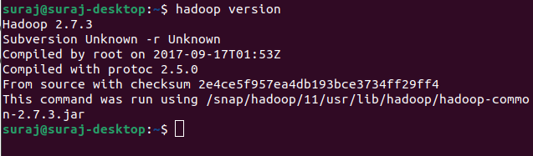

>start-dfs.sh
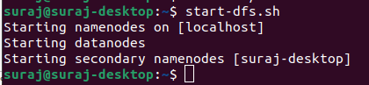

1. Create a directory named by your name
>hdfs dfs -mkdir /suraj
>hdfs dfs -ls /
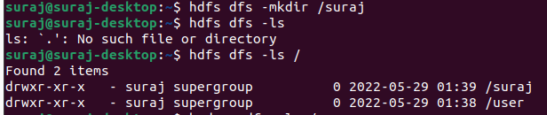

2. Add two empty files into it
>hdfs dfs -touchz /suraj/one.txt
>hdfs dfs -touchz /suraj/two.txt

3. List all the files in the directory that you have created
>hdfs dfs -ls /suraj

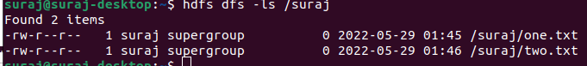

4. Create one more directory by your usn and put that inside the directory of your name
>hdfs dfs -mkdir /suraj/1NT19IS167
>hdfs dfs -ls /suraj
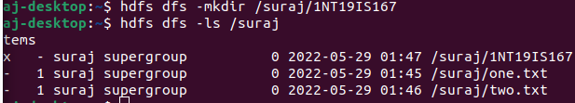
5. Create a file in your local system by the name_usn.txt and add the contents as "Syntax to list Is command is hdfs dfs -Is "
>cat > suraj_1NT19IS167.txt
>"Syntax to list ls command is hdfs dfs -ls"

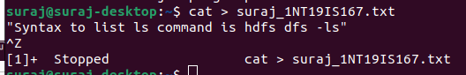

►Put the file usn_name.txt in your hdfs directory called usn
>hdfs dfs -touchz /suraj/1NT19IS167/1NT19IS167_suraj.txt
>hdfs dfs -ls /suraj/1NT19IS167
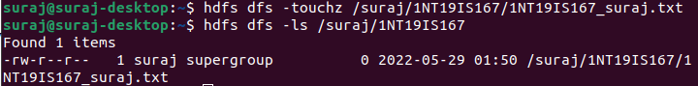

➤Put empty file of hdfs into the local file system
>hdfs dfs -copyToLocal /suraj/1NT19IS167/1NT19IS167_suraj.txt
>ls
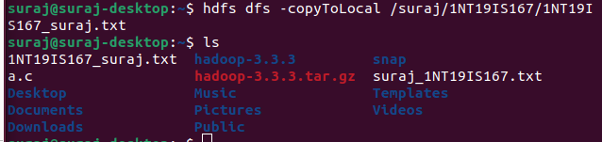

►Use mv command to move files from local file system and hdfs file system
>hdfs dfs -mv /suraj/two.txt /suraj/1NT19IS167
>hdfs dfs -ls /suraj/1NT19IS167
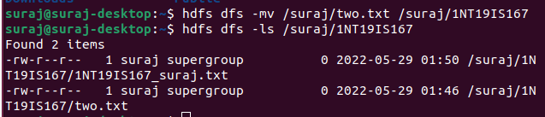

▸ Experiment of cp command
>hdfs dfs -cp /suraj/one.txt /suraj/1NT19IS167
>hdfs dfs -ls /suraj/1NT19IS167
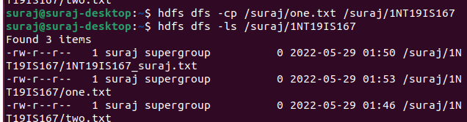

► Display the total size of all the files in name directory
>hdfs dfs -du /suraj
>hdfs dfs -du -s /suraj
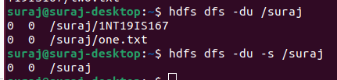

► Display each file size in usn directory Use stat command on name and usn directories
>hdfs dfs -du /suraj/1NT19IS167
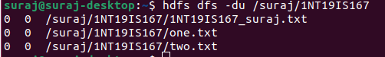

➤ Illustrate the use of append command
cat > one.txt
Hello
^Z
[4]+ Stopped cat > one.txt
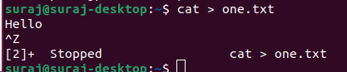

>hdfs dfs -appendToFile one.txt /suraj/1NT19IS167/two.txt
>hdfs dfs -cat /suraj/1NT19IS167/two.txt

